**Task1**

Step 1 – Install Nginx on the local host

Sudo apt update

Sudo apt install nginx

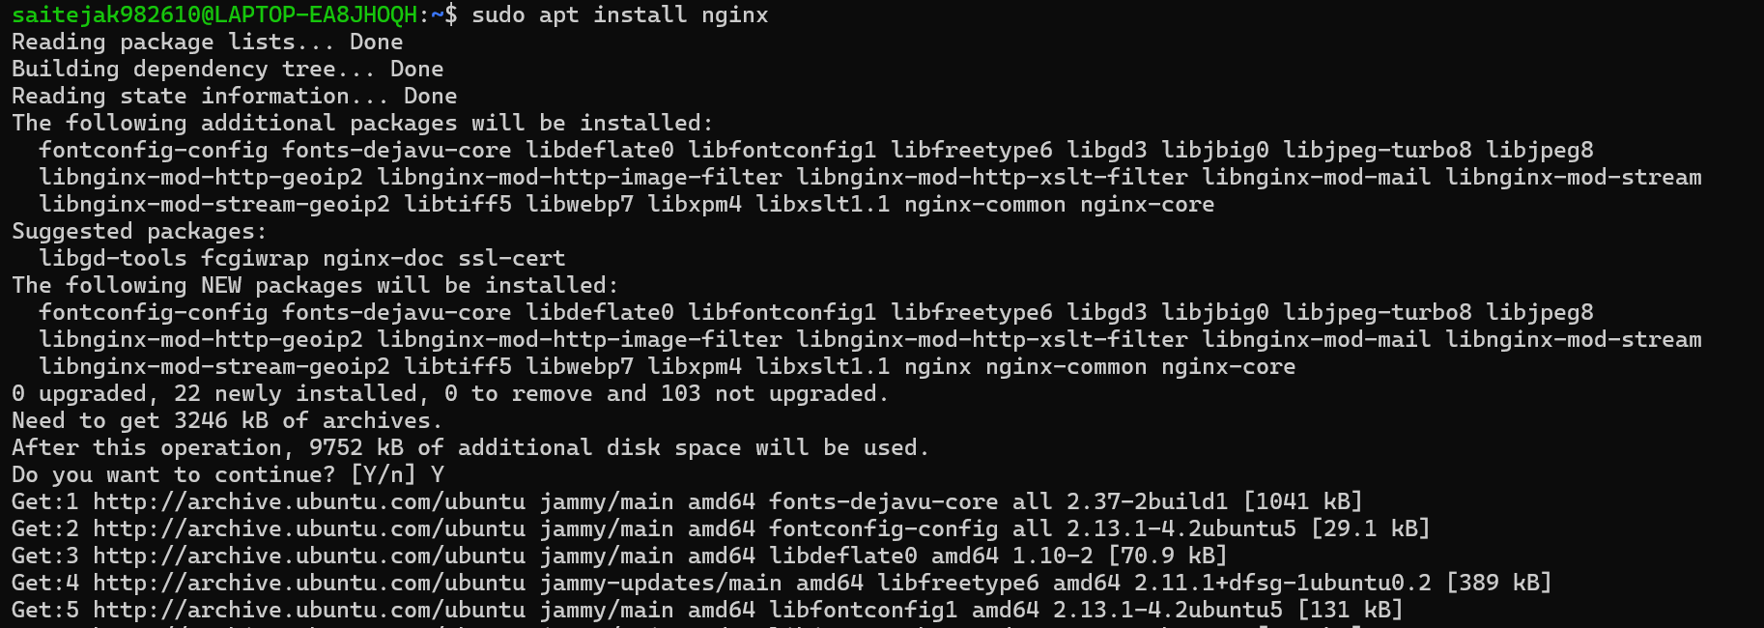

Step 2 – Run the Nginx service

sudo service nginx start

sudo service nginx status



Step 3 – configure a website, create directory where we can store files related to our website.

Sudo mkdir -p /var/www/awesomeweb

Create an index.html file with your web page content and set the permissions to owner for the current username to be able to edit that file.

Sudo chown username:filepath.

After viewing/editing the contents of the file change back the ownership of the file to webserver

Sudo chown -R www-data:www-data /var/www/awesomeweb



Step 4- Setting up a server block

sudo nano /etc/nginx/sites-available/awesomeweb and below content.

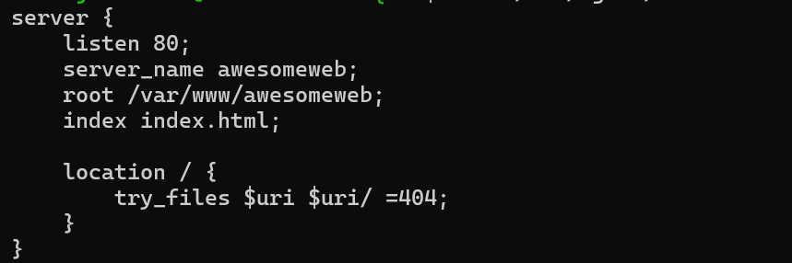

Step 5 – enable a link for the new site and remove default config .

sudo ln -s /etc/nginx/sites-available/awesomeweb /etc/nginx/sites-enabled/

sudo rm /etc/nginx/sites-enabled/default

Step 6 – Restart the nginx service and update the host file

Sudo service restart nginx

Sudo nano /etc/hosts with content 127.0.0.1 awesomeweb

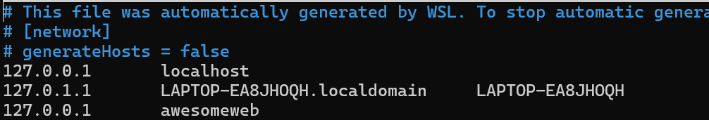

**Task 2** -

The below code can be used to monitor the health of multiple subdomains.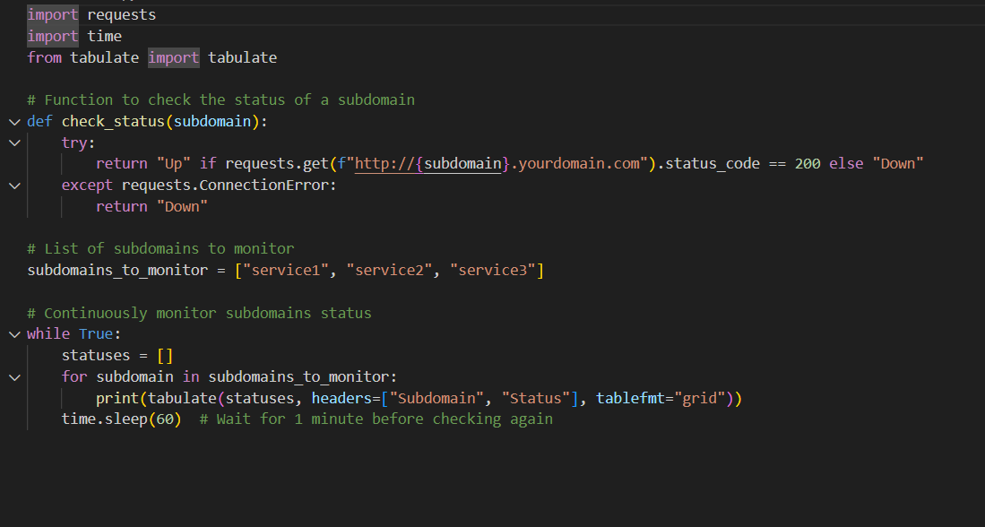

Need to install dependencies like requests and tabulate using the pip command, replace the ypurdomain.com with your actual subdomain.

And the result will be printed in a tabular format.

Task 3 –

Step 1 – Install ubuntu ISO image <https://ubuntu.com/download/desktop>

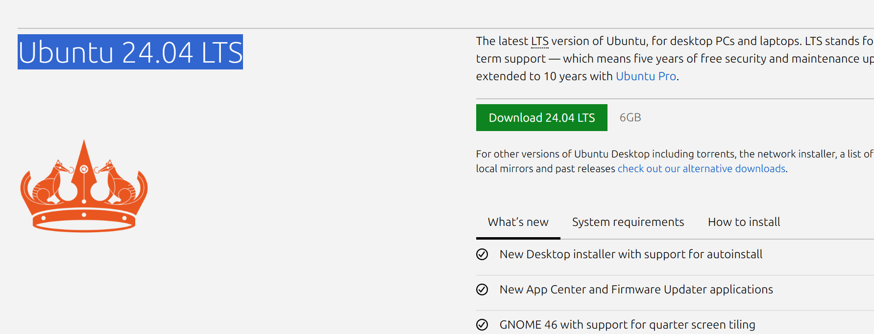

Step 2 – Installing Virtual box from https://www.virtualbox.org/  and select package according to your local OS.



Step 3 – Click on new and create a virtual machine, Open the ubuntu image from the virtual box and allocate some resources to it according to your local host configurations.

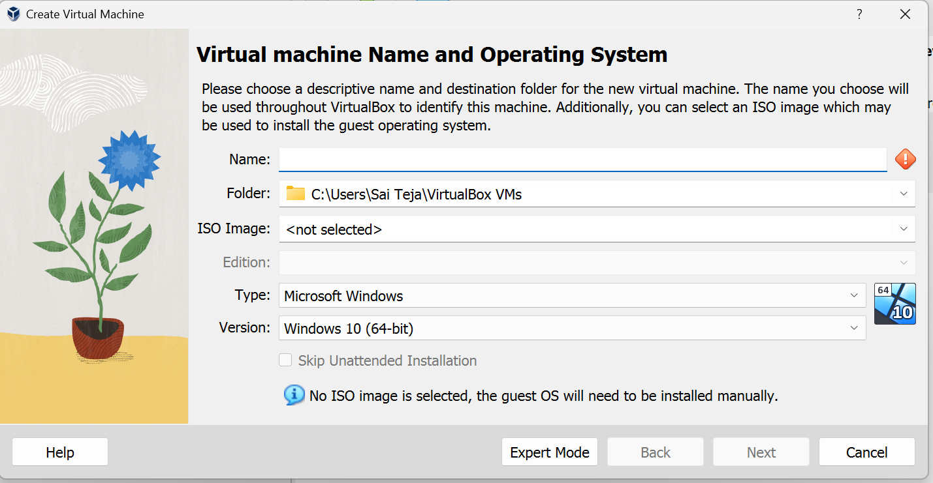

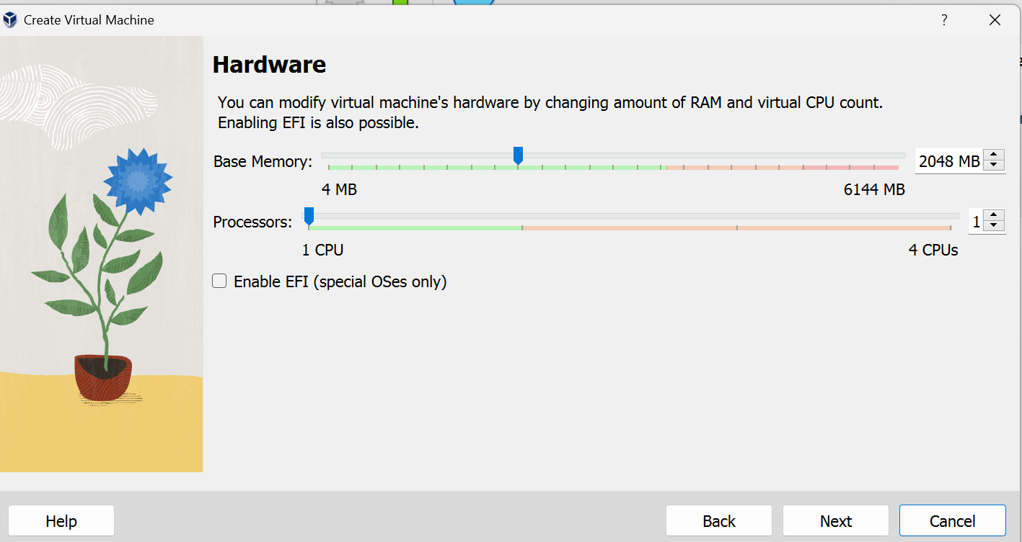

Step 4 – Install the ubuntu on the virtual machine by selecting relevant language (English) and if necessary additional drivers.

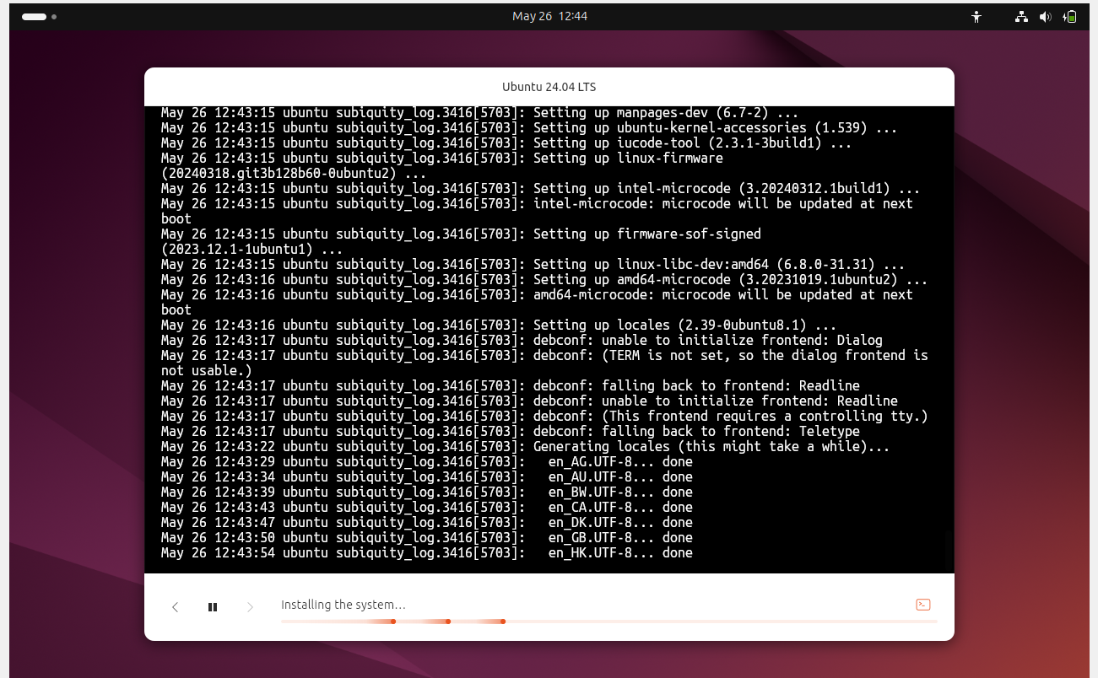

Step 5 – Install Nginx with commands

Sudo apt install nginx

Sudo systemctl enable nginx

Sudo systemctl start nginx

Step 5- Paste the below config file in the path of /etc/nginx/sites-available/awesomeweb

1. server {
2. listen 80;
3. listen [::]:80;
4. server_name awesomeweb;
6. location / {
7. proxy_pass http://127.0.0.1:5000;
8. proxy_set_header Host $host;
9. proxy_set_header X-Real-IP $remote_addr;
10. proxy_set_header X-Forwarded-For $proxy_add_x_forwarded_for;
11. proxy_set_header X-Forwarded-Proto $scheme;
12. }
13. }

Step 6 – Update the hosts file with 127.0.0.1 awesomeweb

Sudo nano /etc/hosts



Step 7 – Check if the relevant port is open using nmap.

